**PIZZA SALES SQL QUERIES**

**A ) KPI’S**

1. Total Revenue

select sum(TOTAL_PRICE) as TOTAL_REVENUE from PIZZA;

Result :

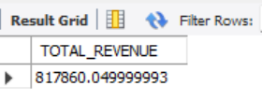

1. Avg. Order Value

select sum(TOTAL_PRICE)/count(distinct ORDER_ID) as AVG_ORDER_VALUE from pizza;

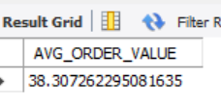

1. Total Pizza Sold

select sum(QUANTITY) AS TOTAL_PIZZA_SOLD from pizza;

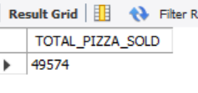

1. Total Order Receiver

select count(distinct ORDER_ID) AS TOTAL_ORDER_RECEIVED from pizza;

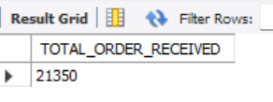

1. Avg. Order Per Quantity

select cast(count(QUANTITY) as decimal(10,2))/cast(count(distinct ORDER_ID) as decimal (10,2))AS AVG_ORDER_QUANTITY from pizza;

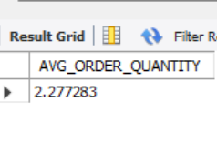

**B) CHARTS**

1. Daily trend of orders

select dayname(order_date) as order_day, count(distinct order_id) as total_orders from pizza

group by order_day;

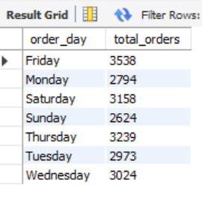

1. Monthly Trend Of Orders

select monthname(order_date) as order_month , count(distinct order_id) as count_orders from pizza

group by order_month

order by count_orders desc;

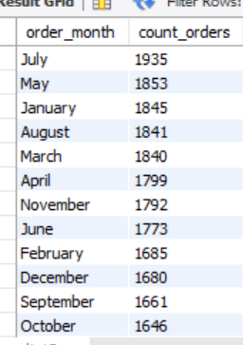

1. Hourly Trend Of Order

select concat(hour(order_time),':00') AS hour_of_sale,count(distinct order_id) as total_quantity from pizza

group by hour_of_sale

order by total_quantity desc;

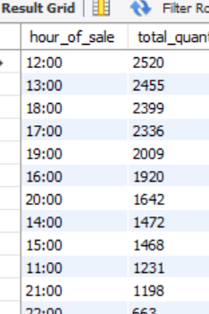

1. Percentage of sale by category

select pizza_category,(sum(total_price) *100 /(select sum(total_price) from pizza)) as percentage_of_sale from pizza

group by pizza_category;

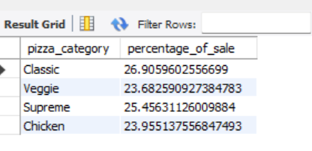

1. Percentage of sale by pizza size

select pizza_size,cast(sum(total_price) *100 / (select sum(total_price) from pizza)as decimal (10,2))

as percentage_of_sale from pizza

group by pizza_size;

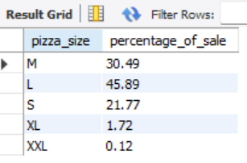

1. Top 5 Pizza By Revenue

select pizza_name_id,sum(total_price)as total_revenue from pizza

group by pizza_name_id

order by total_revenue desc

limit 5;

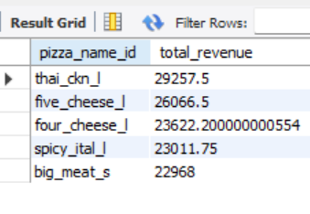

1. Top Botton Pizza By Revenue

select pizza_name_id,sum(total_price)as total_revenue from pizza

group by pizza_name_id

order by total_revenue asc

limit 5;

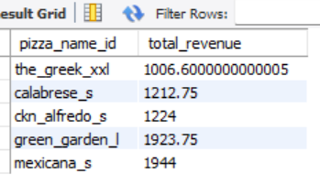

1. Top 5 Pizza Sale By Quantity

select pizza_name_id,sum(quantity)as total_quantity from pizza

group by pizza_name_id

order by total_quantity desc

limit 5;

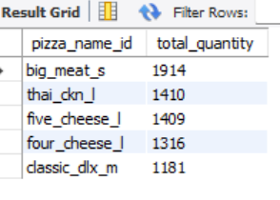

1. Top Botton Pizza Sale By Quantity

select pizza_name_id,sum(quantity)as total_quantity from pizza

group by pizza_name_id

order by total_quantity asc

limit 5;

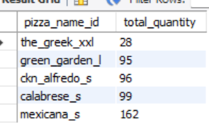

1. Top Pizza Sale By Orders

select pizza_name_id,count(distinct order_id) as total_orders from pizza

group by pizza_name_id

order by total_orders desc

limit 5;

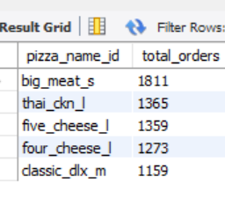

1. Top Bottom Pizza Sale By Orders

select pizza_name_id,count(distinct order_id) as total_orders from pizza

group by pizza_name_id

order by total_orders asc

limit 5;

